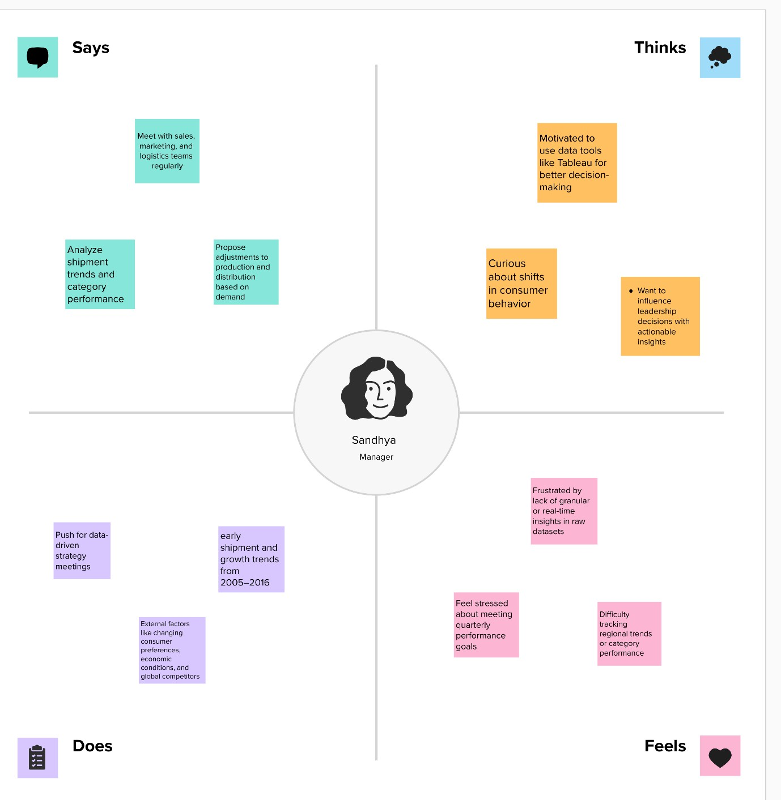

IDEATION PHASE

EMPATH
IZE & DISCOVER

Date

FEB 2026

Tea
m ID

SBAP0031863

Project Name

T
oy
C
raft tales: tableau's vision into
toy manufacturer data

Maximum Marks

4

Marks

